LW: Setting up your Mac for CSCE 121

# For the first week only, you can complete this labwork on your own and do not have to attend lab to get credit.

We will be using a common compiling environment for all students in the class, regardless whether you use macOS, Windows, or a Linux distribution. The way we have decided to do this is to have all students compile in a command line environment, i.e. the “Terminal” application.

# Installing gcc, a C++ Compiler

1. Launch the “Terminal” application. This can be done by the following sequence of steps:  
   1. Press cmd+space to launch Spotlight Search.   
      
   2. Type Terminal in the Spotlight Search field. A list of results should automatically populate. 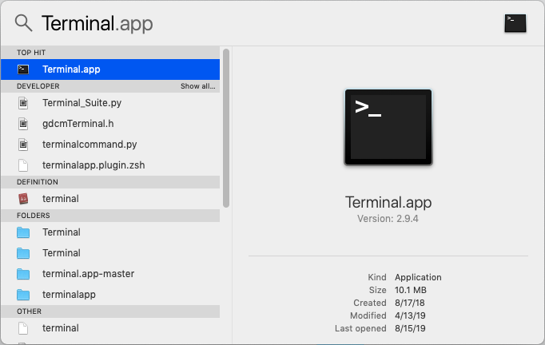
   3. Click on Terminal.app to launch Terminal.   
      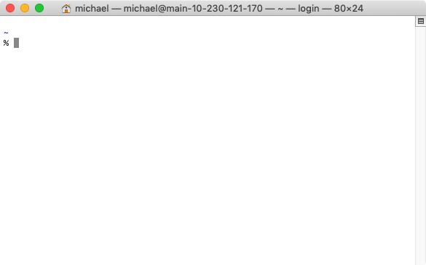
2. In the Terminal application, type xcode-select --install and press enter to install the C++ compiler.  
   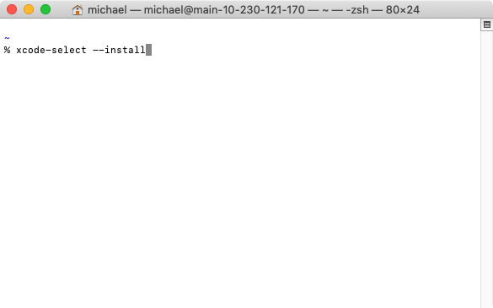

# Text Editor Installation (optional)

You will want a text editor with syntax highlighting. Although it is not strictly necessary, it really makes reading code much easier.

## Text editor options for Mac:

* [Sublime](https://www.sublimetext.com/)
* [Atom](https://atom.io/)
* [Visual Studio Code](https://code.visualstudio.com/)

# Acknowledgment

Link to acknowledgement of completion is in eCampus.